**WhatsApp Helper - Manual Installation Guide**

Thank you for trying out **WhatsApp Helper**! Since the extension is still under review on the Chrome Web Store, you can manually install it by following the steps below.

**Step 1: Download the Extension Zip File**

* Check your email or messaging platform where you receive the zip file.
* Download the zip file to your computer.
* The file will likely be saved in the **Downloads** folder by default.

**Step 2: Extract the Zip File**

* Locate the downloaded **WhatsApp Helper.zip** file.
* Right-click on the file and select **Extract All...**.

* Choose a location to extract the files (you can leave it as default) and click **Extract**.

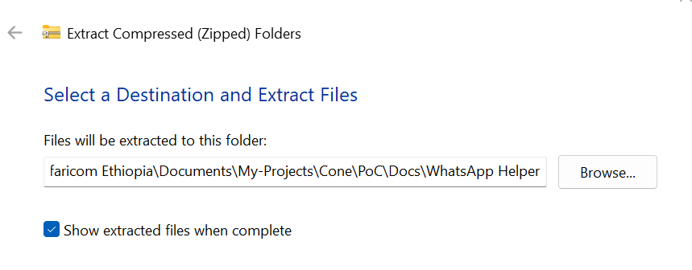

* A new folder named **WhatsApp Helper** will appear with the extracted files.

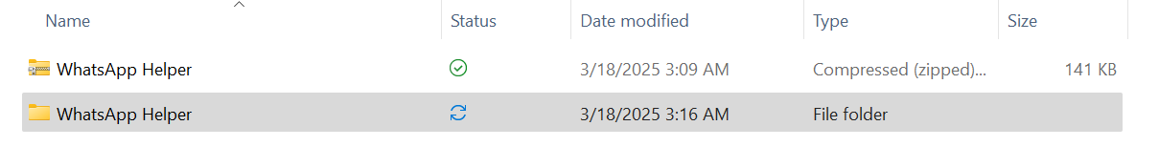

* Inside the **WhatsApp Helper** folder there is the chrome_plugin folder.



**Step 3: Open Chrome Extensions Page**

* Open **Google Chrome** on your computer.
* Click on the three-dot menu (burger menu) in the top-right corner of Chrome.
* Hover over **More tools**, then click **Extensions**.

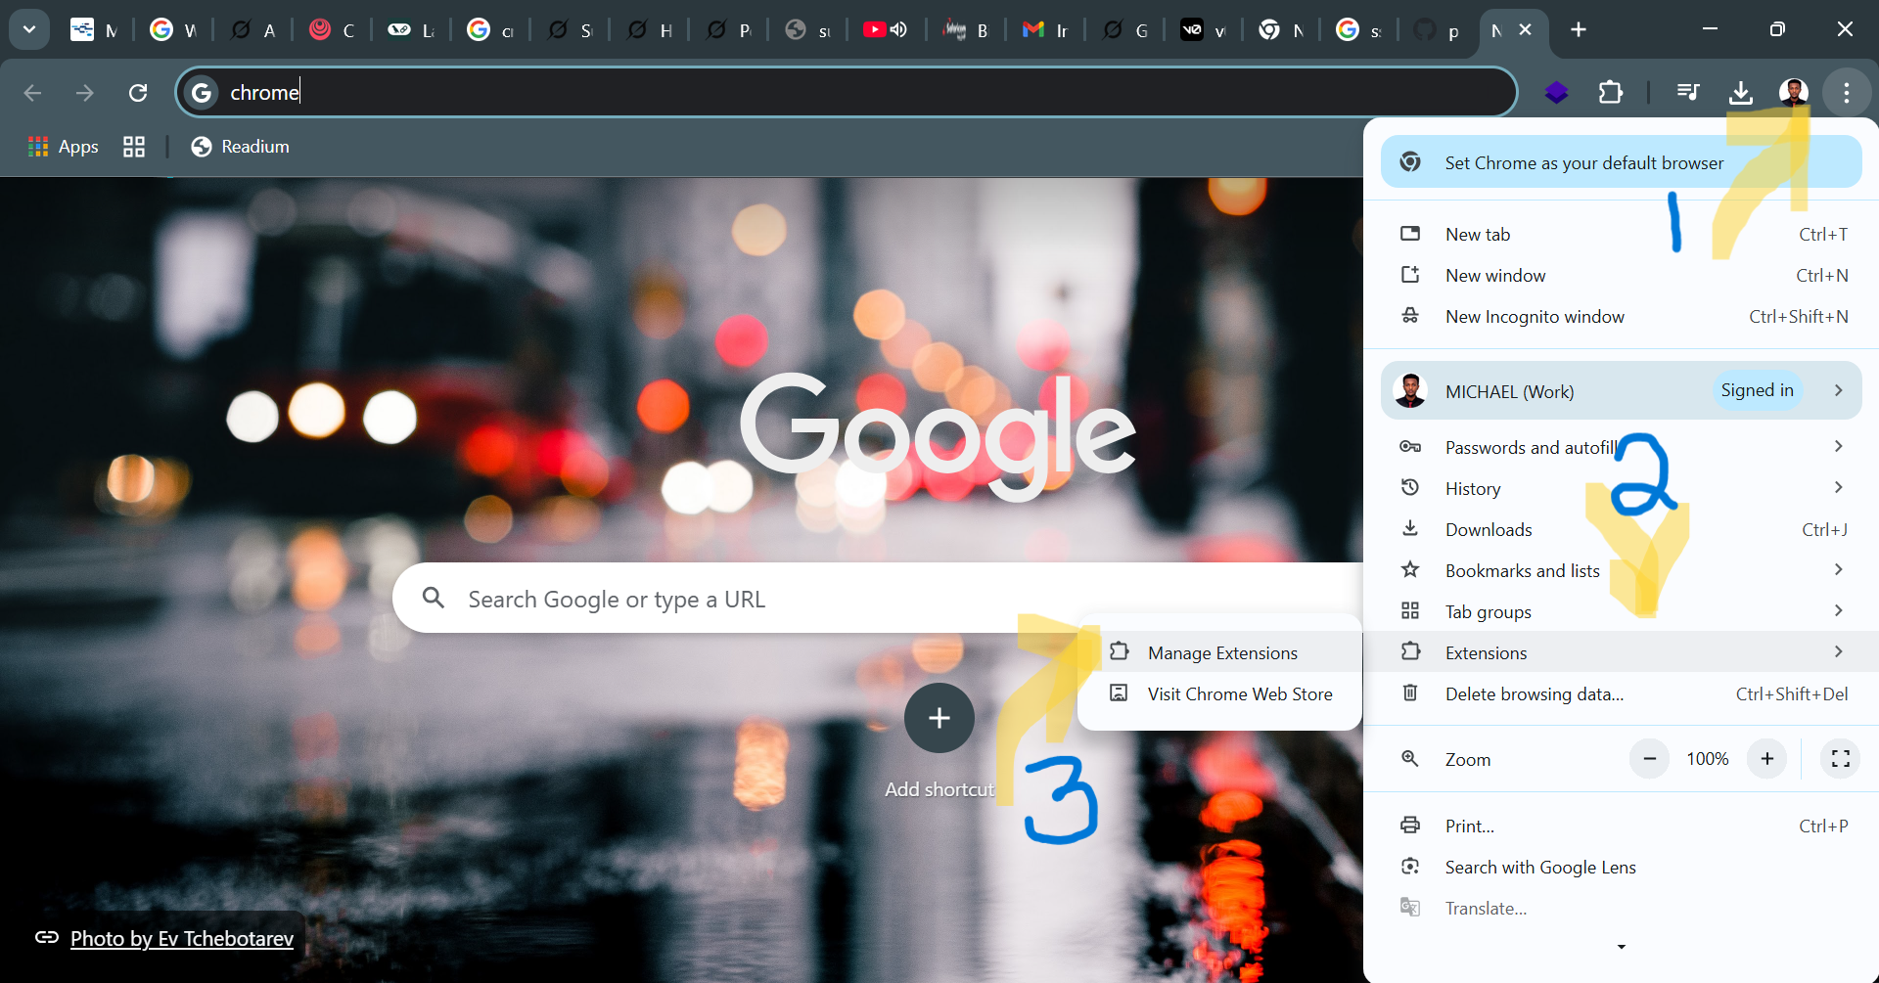

* This will open the **Extensions** management page.

**Step 4: Enable Developer Mode**

* In the **Extensions** management page, look at the top-right corner.
* Turn on the switch for **Developer mode**.

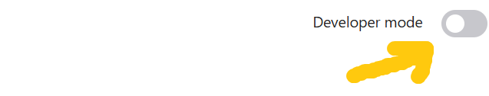

**Step 5: Load the Extension**

* Click on the **Load unpacked** button at the top left.

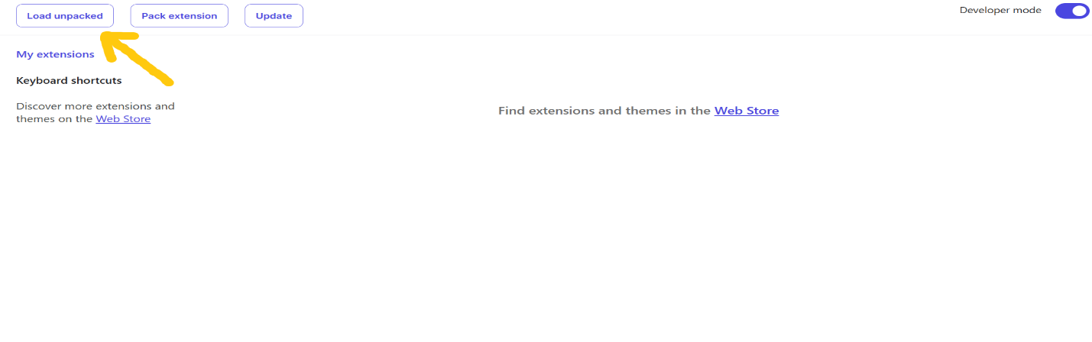

* A window will appear asking you to select a folder.
* Navigate to the folder where you extracted the WhatsApp Helper extension and select the inner folder chrome_plugin.
* Select the extracted folder and click **Select Folder**.

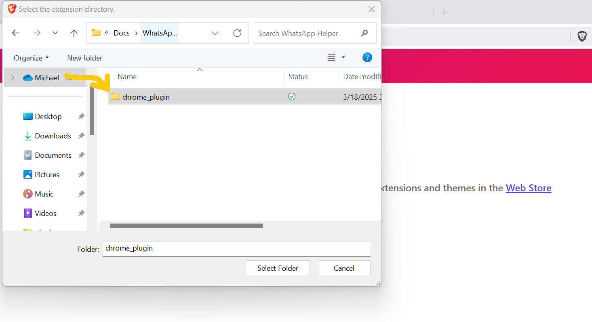

***Note: Don’t forget to go inside the folder before clicking on the ‘Select Folder’ button.***

* The WhatsApp Helper extension should now appear in your list of extensions.

**Step 6: Enable the Extension**

* If the extension is not already enabled, find **WhatsApp Helper** in the list of extensions and turn on the switch.

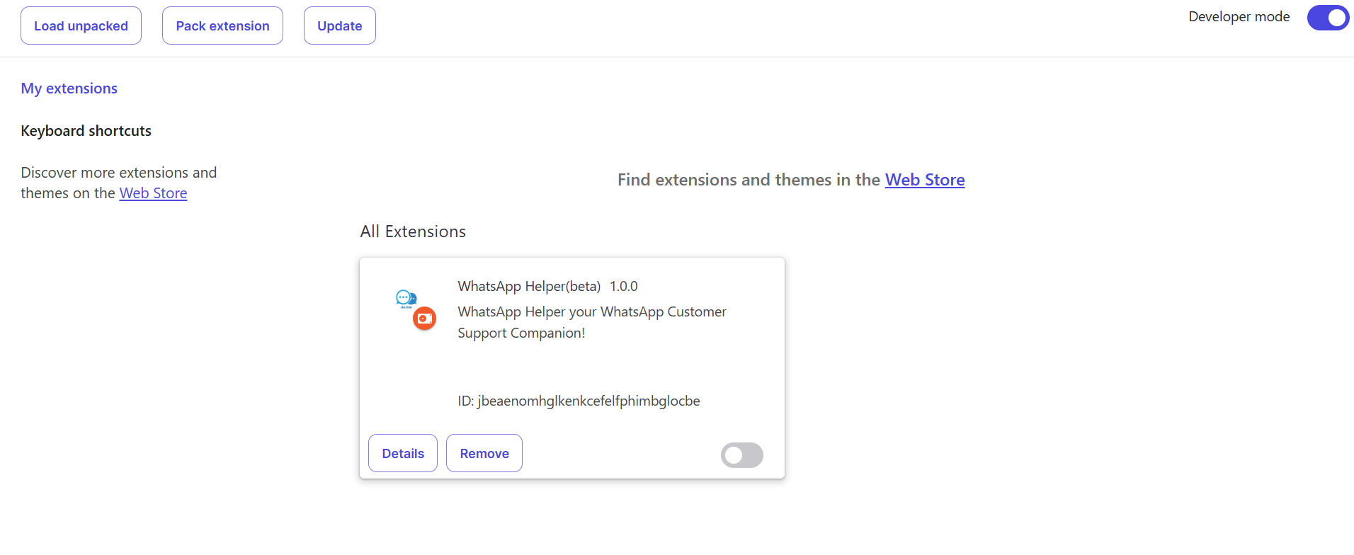

***Note: Don’t forget to enable the extension if it is not enabled as shown below.***

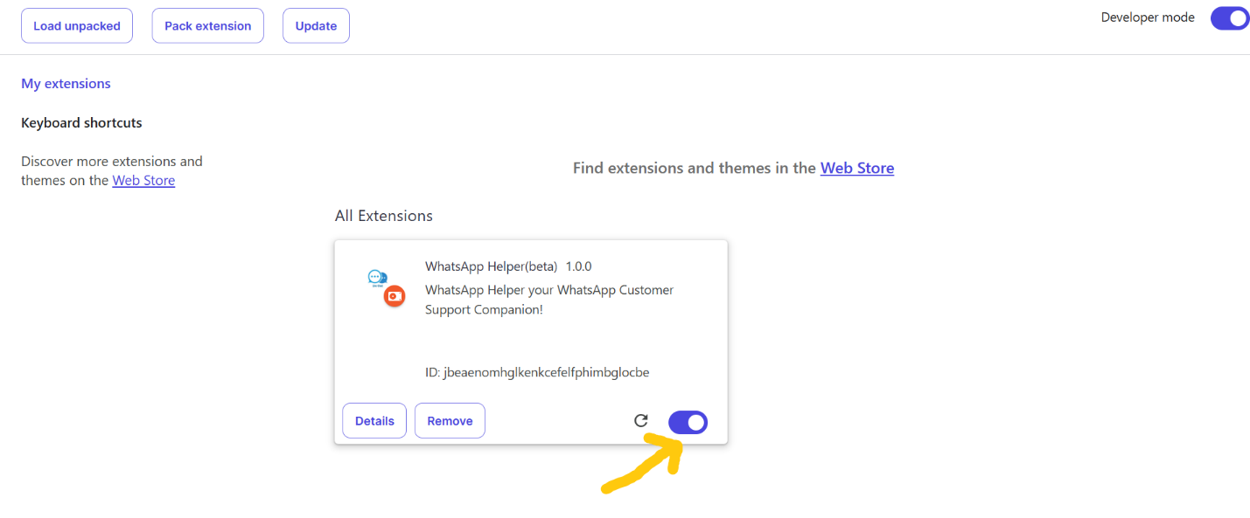

* You should now see the WhatsApp Helper icon appear near the Chrome address bar.

**Step 7: Start Using WhatsApp Helper**

* Open the WhatsApp Page that you want to monitor and manage with the help of WhatsApp Helper on the other tab.
* Click on the WhatsApp Helper icon to open it and start using the features.

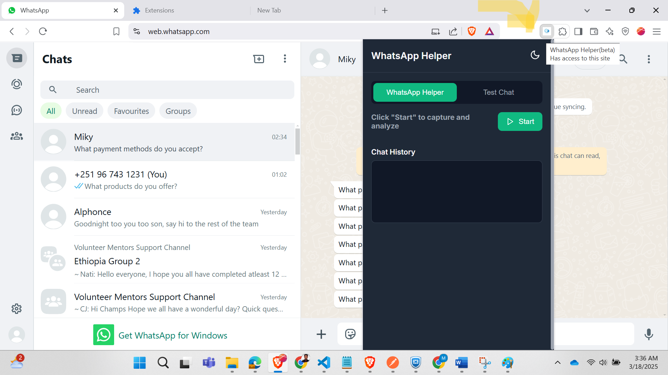

* If you encounter any issues, try refreshing WhatsApp Web or restarting Chrome.

**Step 8: Choose the Flavor of WhatsApp Helper**

* You can choose WhatsApp Helper and click on start if you have unread messages, and you want to monitor them automatically.
* You can choose Test Chat if you want to write and test the system by prompting it with questions like your customers.

**Need Help?**

If you have any questions or issues, feel free to reach out for assistance. Enjoy using **WhatsApp Helper**!